TITLE (12 pt, font Times New Roman, Bold)

First Author¹, Second Author²(10 pt, , font Times New Roman)
¹(Author Affiliations)
²(Authors Affiliations)
(Corresponding Author Email id)
--------------------------------------------------------------------------------------------------------------
Keywords: component; formatting; style; styling; insert (keywords) (10 pt, font Times New Roman)

ABSTRACT: (10 pt, font Times New Roman, Bold, Italic)
This already defines the components of your paper (title, text, heads, etc.). Do Not Use Symbols, Special Characters or Math in Paper Title or Abstract. (Abstract) (10 pt, font Times New Roman, Italic)

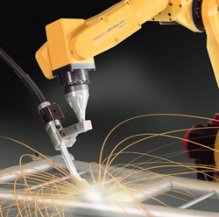

Figures 1: Xxxxxxx xxxxxxx (9 pt, font Times New Roman)

REFERENCES (10 pt, font Times New Roman, Bold)

Journal Papers:
- M Ozaki, Y. Adachi, Y. Iwahori, and N. Ishii, Application of fuzzy theory to writer recognition of Chinese characters, IOSR Journal of Engineering, 2(2), 2012, 112-116.

Note that the journal title, volume number and issue number are set in italics.

Books:
- R.E. Moore, Interval analysis, Englewood Cliffs, NJ: Prentice-Hall, 1966.

Chapters in Books:
- P.O. Bishop, Neurophysiology of binocular vision, in J.Houseman (Ed.), Handbook of physiology, 4 (New York: Springer-Verlag, 1970) 342-366 (9 pt, font Times New Roman)

Note that abstract should not be longer than one page!

